Zepr - Zombie Engineering Project

User Manual

## 

## Contents

## 

#### Introduction ..………………………………………………………………………………...02

#### Main Menu ..…………………………………………………………………………………03

#### Stage and Character Selection ……………………………………………………………….04

#### Pause Menu ………………………………………………………………………………….05

#### Gameplay …………………………………………………………………………………….06

## 

#### Full list of characters and power-ups ...………………………………………………………08

## 

## 

## 

## Introduction

#### Scenario

After a hard night of partying after the dreaded POPL exam, you wake up to find yourself in the middle of town, your friends nowhere to be found. What great friends they were.

As you try and recall how you ended up here, you hear a low rumbling sound coming from the alleyway near you, and that isn’t a result of your hangover.

A horde of decaying zombies suddenly appears out from the alleyway, their clothes tattered, blood and bone sticking out of their bodies.

Not soon after, the zombies notice you and charge towards you, trampling over each other, their rumbles turning into screams and cries.

Your Goal is to survive the zombie horde and defeat the bosses to stop them at their source. Meanwhile, you try to keep on top of your University work. As if you weren’t behind already.



## Main Menu

## 

After launching the game, you will be presented with the main menu.

Click “Start” to begin the game.

Click “Exit” to close the game.

## 

## 

## 

## 

## Stage and Character Selection

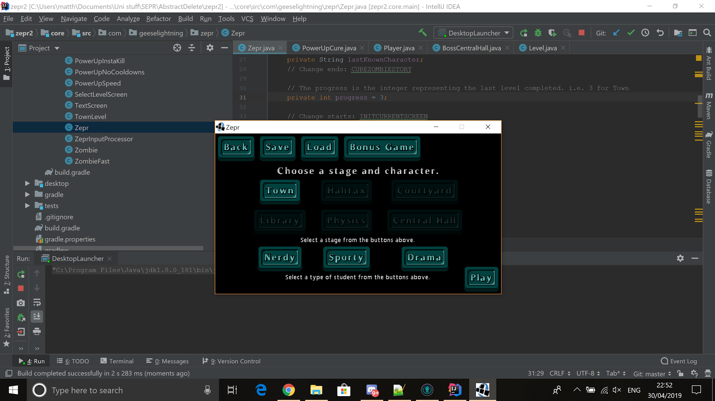

#### Stage

Stage selection allows you to select which stage you wish to play in, where each stage will offer different obstacles and hence require different strategies to overcome.

Select either one of the “Town”, “Halifax”, “Courtyard”, “library”, “Physics” or “Central Hall” buttons. (“Halifax” will be locked until “Town” is completed, and “Courtyard” will be locked until “Town” and “Halifax” are completed and so on.)

Saving at any time on the stage selection screen will save your stage progress, but not your points! So if you want a highscore, you best be ready to beat it all in one run. When you start the game again and press load, your stage progress will be restored.

There is also a bonus game that can be accessed at any time. This allows the player to shoot down infected geese that have infested York in order to earn some bonus points.

#### Characters

Character selection allows you to play as a different character, where each character will offer unique strengths over the other.

Select either one of “Nerdy”, “Drama” or “Sporty”.

## Pause Menu

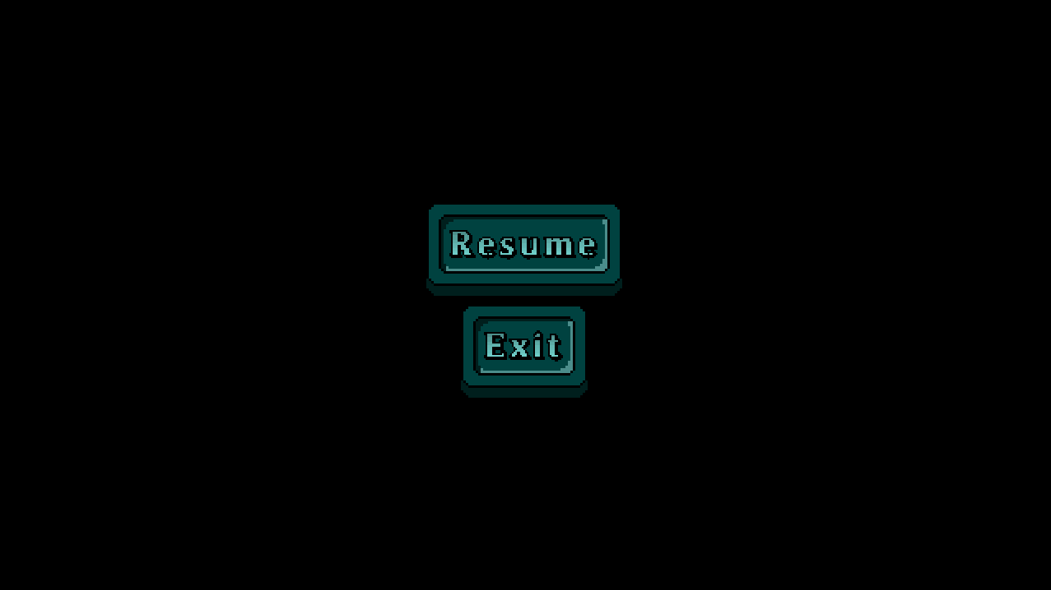

You can pause the game by pressing the “Esc” key.

To return to the game, click the “Resume” button.

To return to the stage selection screen, click the “Exit” button.

## 

## Gameplay

#### Controls

|  |  |
| --- | --- |
| **Key** | **Action** |
| W | Moves the player character up the screen |
| A | Moves the player character left on the screen |
| S | Moves the player character down on the screen |
| D | Moves the player character right on the screen |
| E | Uses the current player character’s special ability |
| LMB (Left Mouse Button) | The attack button. |
| Escape | Brings up the Pause Menu |

#### Graphical Interface

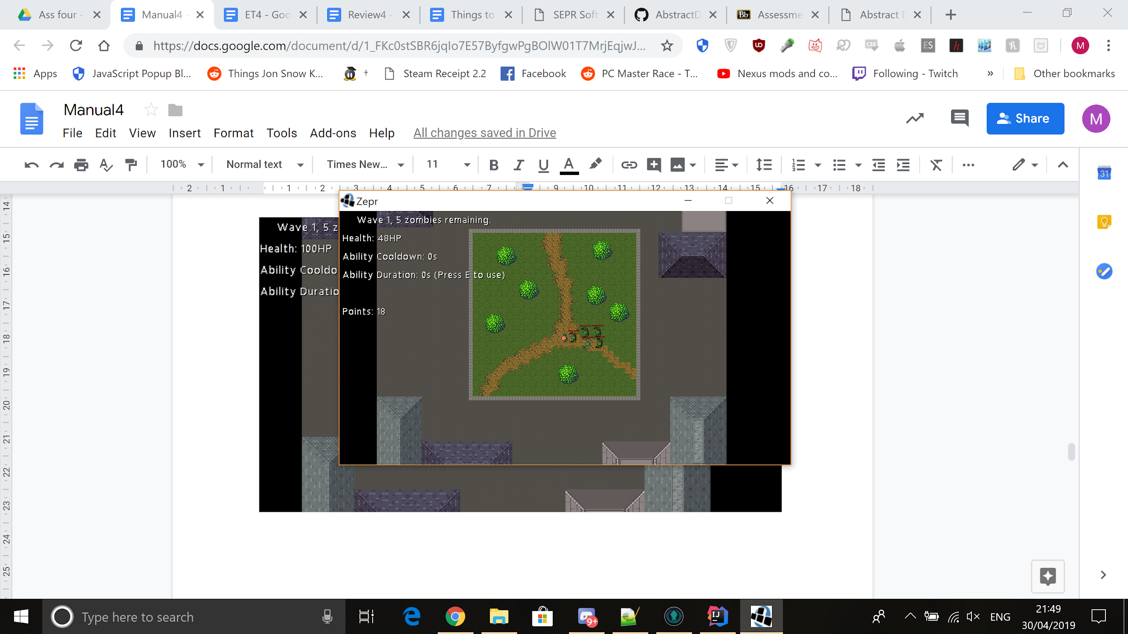

Information on the wave number, the number of zombies remaining in the wave, the player’s health total, and how many points the player has is shown in the top left of the screen.

The player’s current ability cooldown time and how long the current ability lasts are also shown in the top left at all times. This allows the player to plan when to use their abilities.

When a power-up is available it will be displayed in the top left of the screen. When it has been picked up there will be a timer showing the player how long the power-up lasts. And they’re all pretty useful, so best grab them when you can.

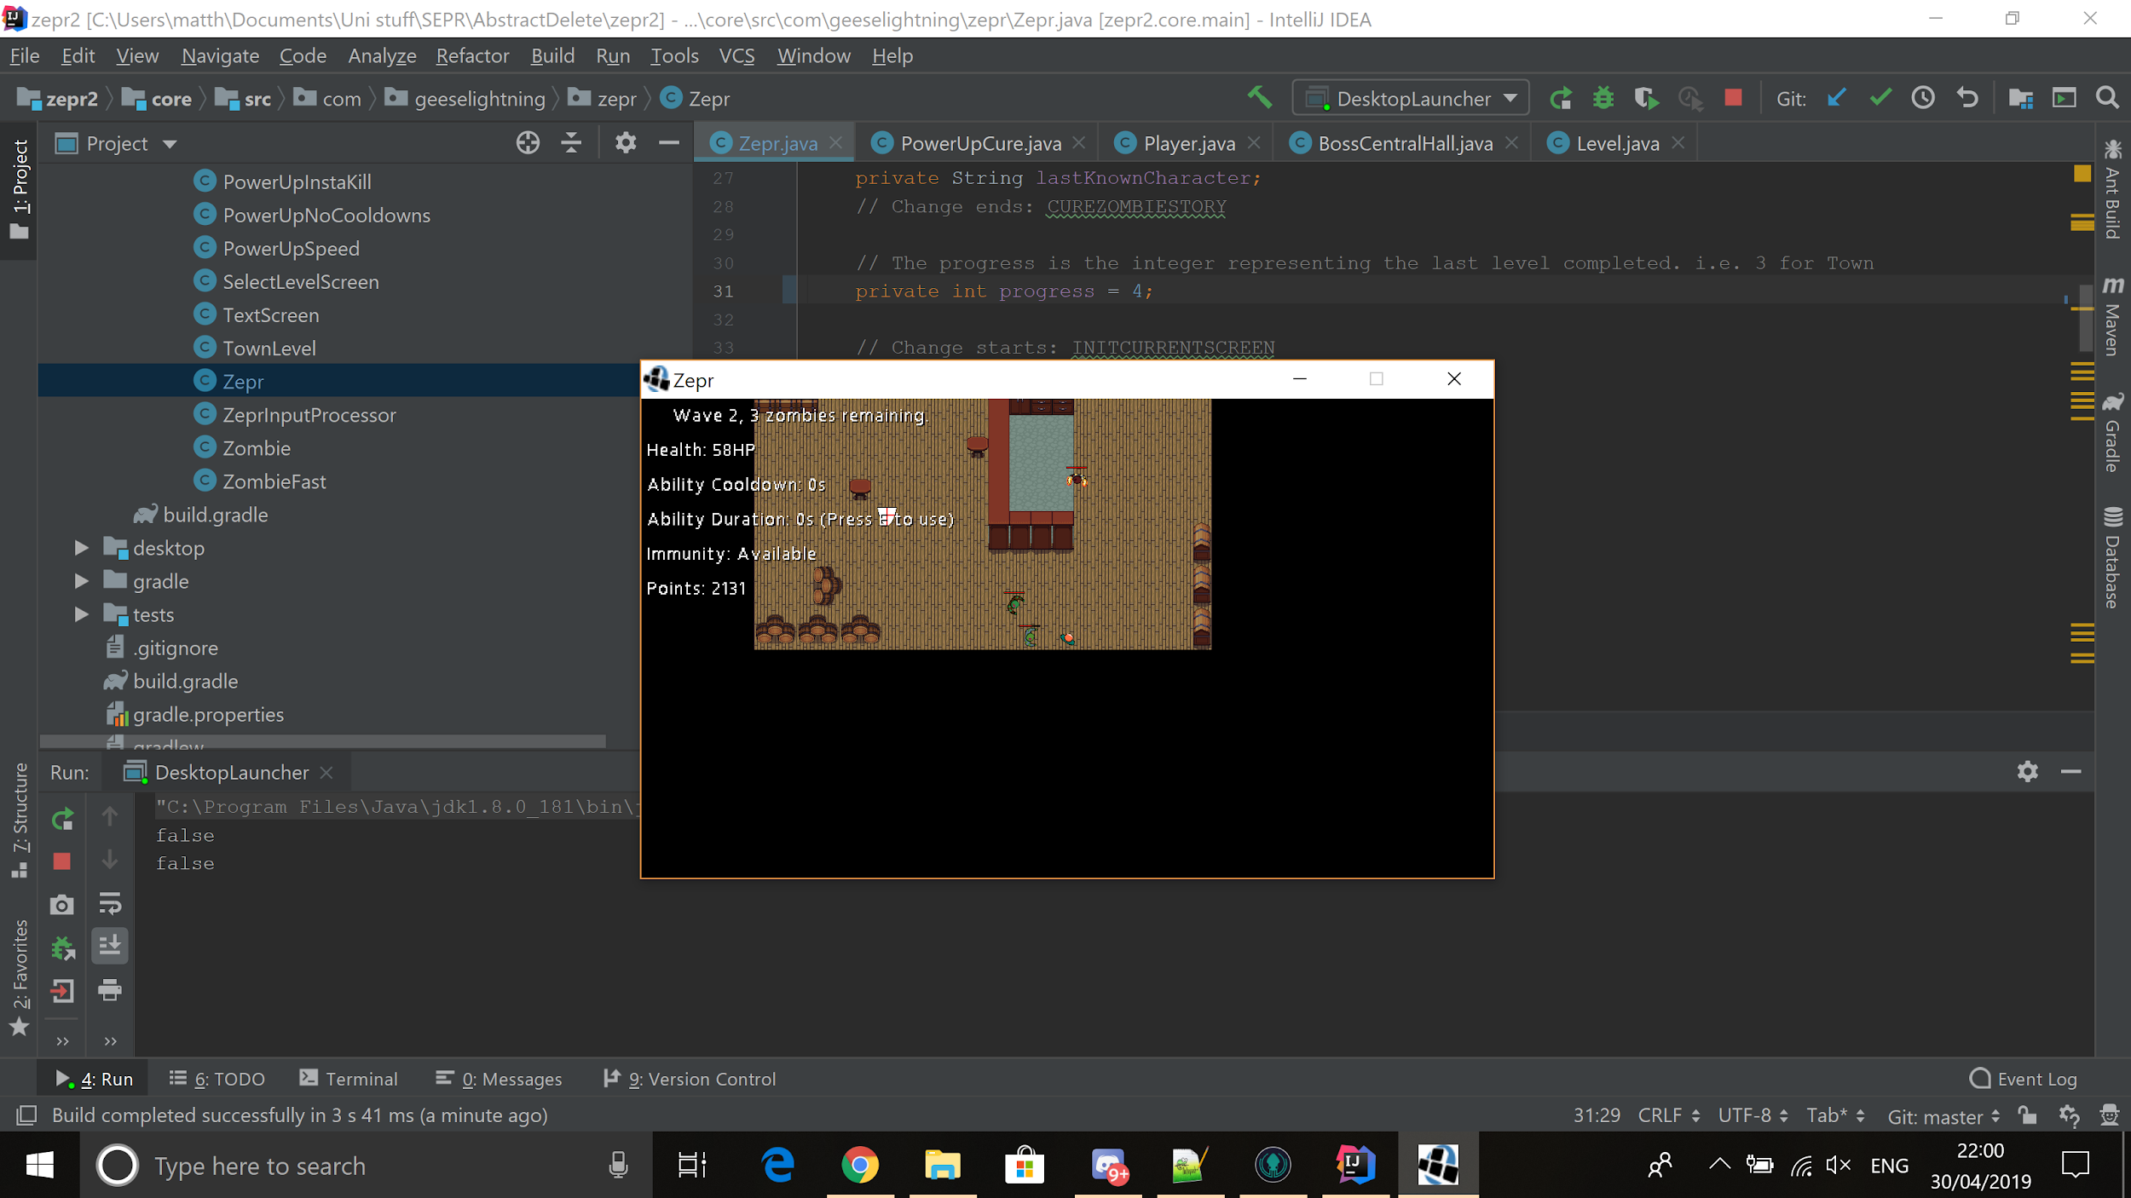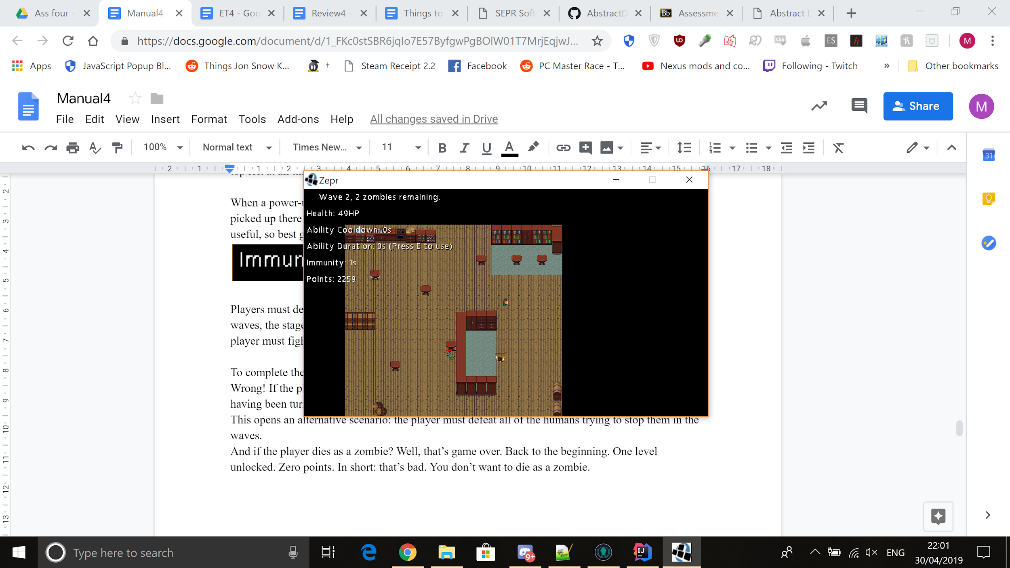

Players must defeat all of the zombies in the wave to progress to the next wave. After completing 3 waves, the stage is complete, and the next stage is unlocked. Apart from on boss stages where the player must fight through an extra fourth wave with a boss.

To complete the game, the player must complete all six stages. Simple right?

Wrong! If the player’s health drops down to 0 during a stage, they will be returned to the main menu, having been turned into a zombie.

This opens an alternative scenario: the player must defeat all of the humans trying to stop them in the waves.

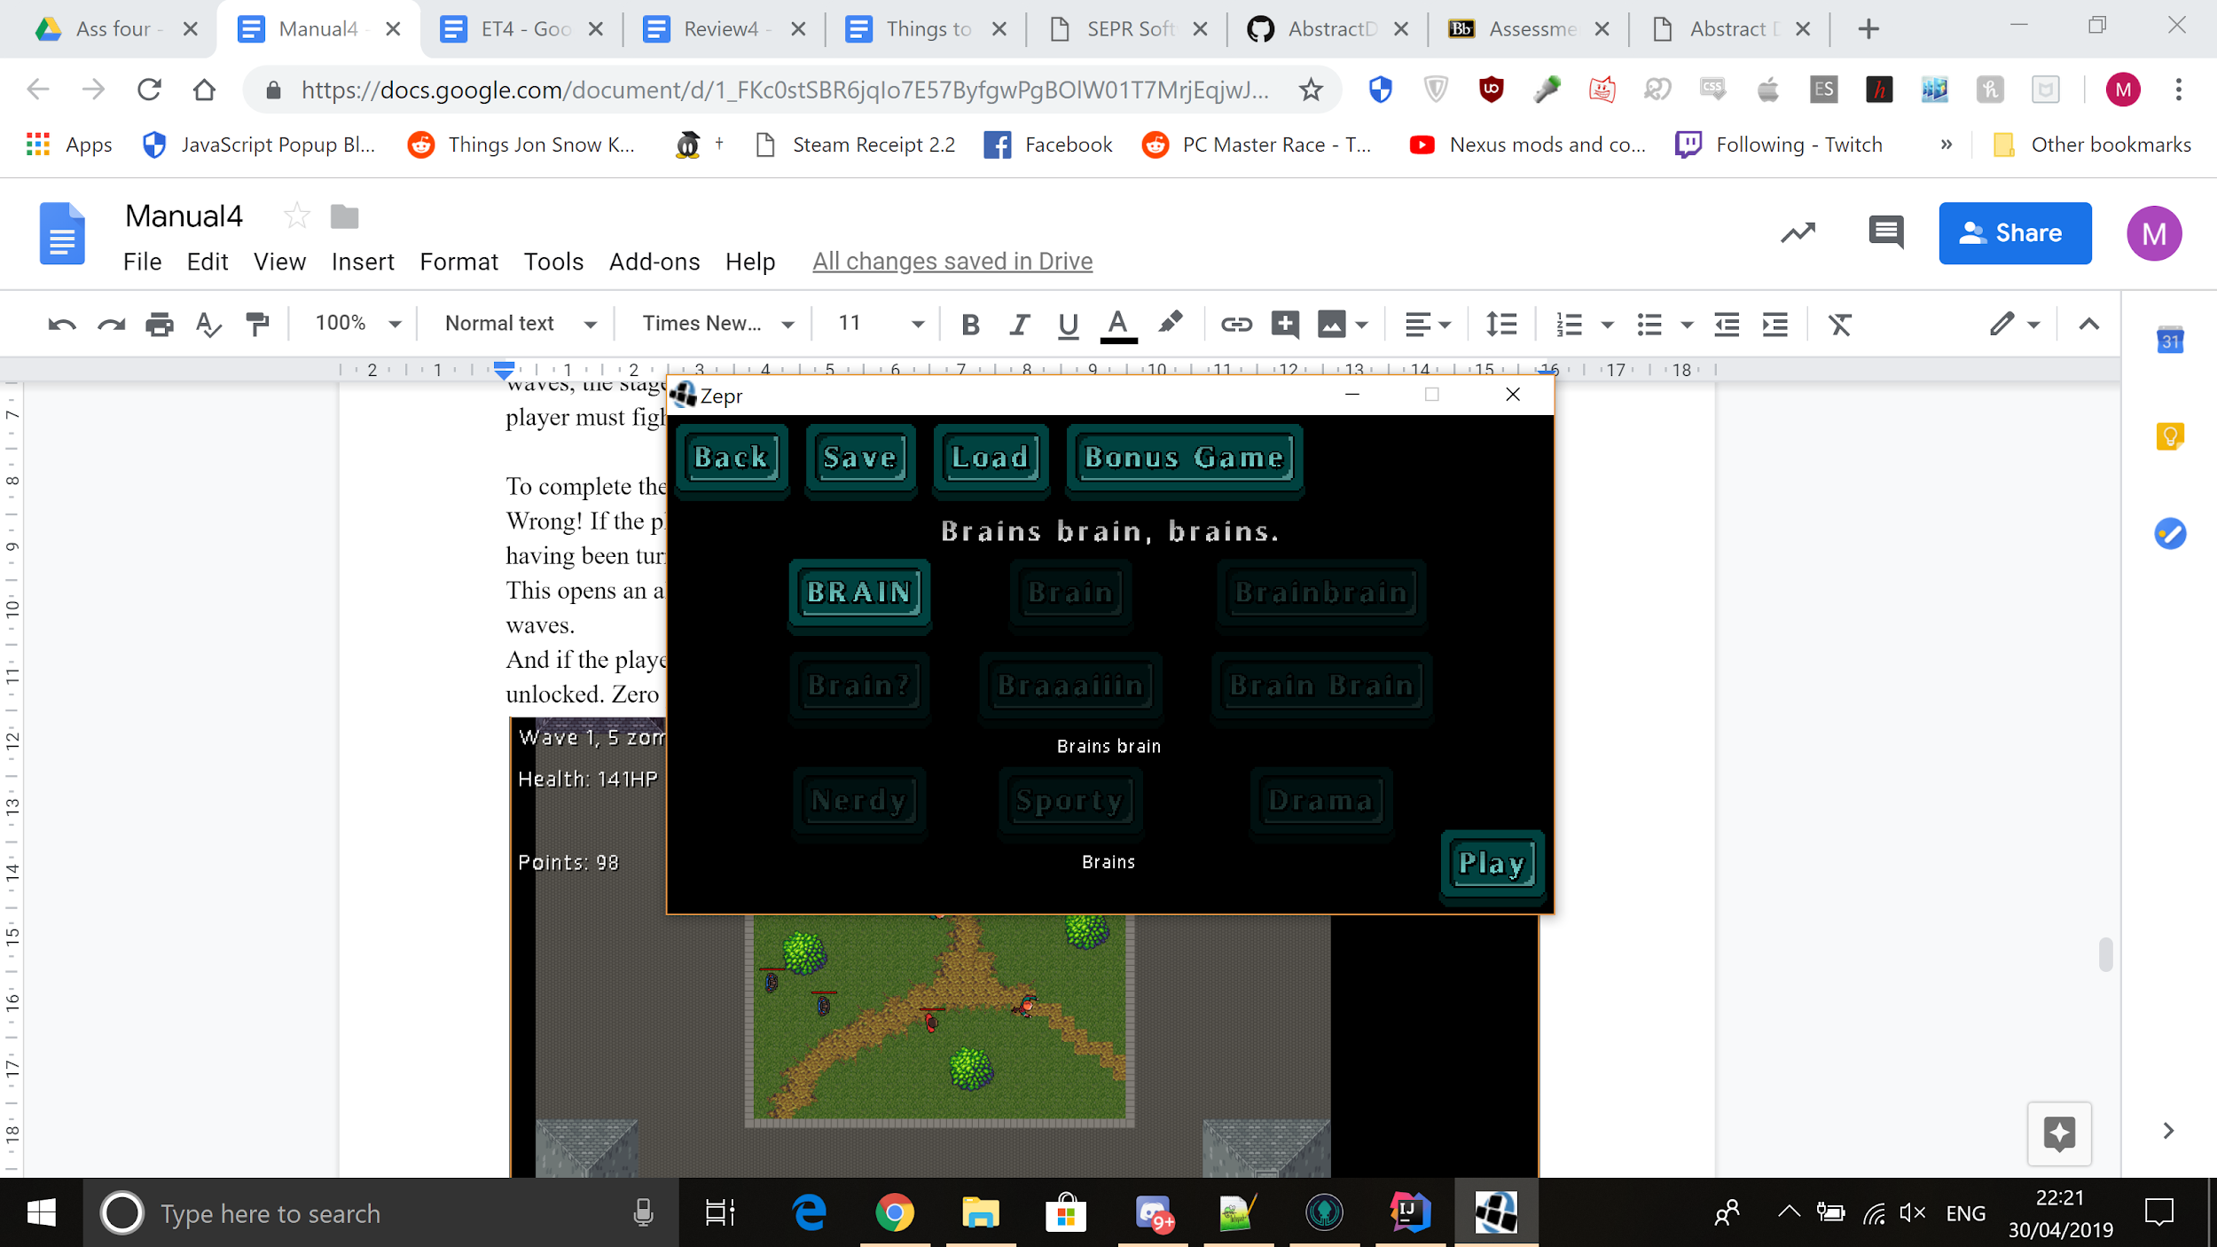

And if the player dies as a zombie? Well, that’s game over. Back to the beginning. One level unlocked. Zero points. In short: that’s bad. You don’t want to die as a zombie.

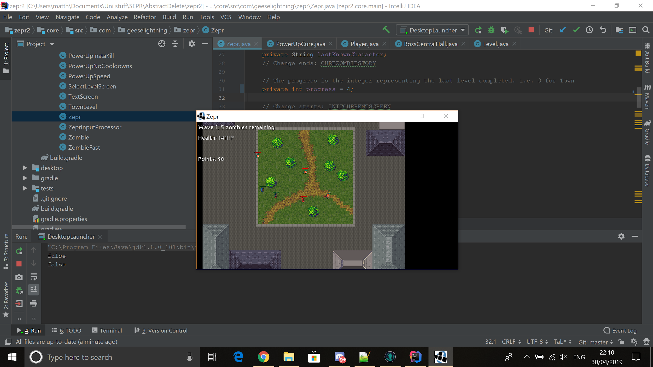

## Full list of Characters and power-ups:

#### Playable Characters:

**Nerdy**



Has higher health.

Ability: power punch

**Sporty**



Has greater mobility.

Ability: sprint

**Drama**



Has greater attack damage.

Ability: fake damage

**Zombie Players**



Take the best aspect from each player type, but are too stupid to use abilities.

#### Power Ups:

**Heal**



Heals the player.

**Speed up**



For the next 10 seconds, increases the movement speed of the player.

**Immunity**



For the next 5 seconds, makes the player immune to attacks.

**INSTAKILL**



For 10 seconds, the player can kill any enemies with one hit.

**No Ability Cooldowns**



For 10 seconds, the character’s ability cooldowns are 0.

**Secret Item**



Is extremely useful after having become a zombie...

#### Easter Eggs:

**Find Zelda!**

